
Photo credit: Danny Kaan

Sennheiser Spectera brings summer nights to life at Secret Cinema’s Grease
Revolutionary wireless audio system delivers immersive experience across massive venue

Marlow, UK, October 2025 – Secret Cinema’s spectacular production of Grease at Evolution London has showcased Sennheiser’s revolutionary Spectera wideband wireless system in a major UK deployment. Having run from early August through the second week of September in Battersea Park, this immersive theatrical experience transported audiences into the iconic world of Rydell High, where the line between screen and reality disappeared entirely. The production’s ambitious scale and unique requirements provided the perfect testing ground for Spectera’s advanced capabilities, with the system far surpassing all expectations.

Set across a large venue spanning 75m by 50m indoors and 50m by 50m outdoors, Secret Cinema’s Grease created a notable challenge for wireless audio coverage. The production featured six different stages inside the venue and another five outside, including a full fairground setting complete with circus ride, bar area with dancers, Shake Shack, and a central podium stage. The performance culminated outside as audiences followed the cast through a funhouse, recreating the film’s famous finale.
Spectera is the world’s first wideband, bidirectional digital wireless ecosystem, offering up to 64 channels in a single unit. The system provides unprecedented control over latency, audio quality, and range, while reducing equipment requirements through its innovative bidirectional bodypacks that handle both microphone and in-ear monitor signals simultaneously.
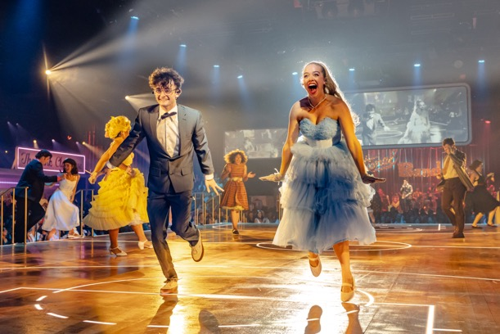 | Secret Cinema’s Grease immerses the audience fully in the world of Rydell High  Photo credit:  Danny Kaan
Sound Designer, Gareth Fry, explains the unique demands of the production: “It’s a massive venue. Everywhere is a stage, everywhere is an audience space. The performances and the audience are mingling with each other and that was one of the key points of the show – to create that immersive effect and make the audience feel like they’re completely in the world of Rydell High and iconic scenes from Grease.”
The Spectera system successfully provided comprehensive coverage for 30 cast members, delivering 40 microphone and 10 IEM mixes across the entire venue. This was achieved using just two Base Stations and a total of eight DAD Antennas operating on two TV channels.
“This was us testing Spectera to its limits on its first big outing,” says Fry. “With the cast all wearing mics at the same time, to get that coverage using a traditional system would have been very difficult, expensive, and used up a lot of our time.”
The system’s bidirectional capabilities proved transformative for the production. Cast members needed only a single beltpack that handled both microphone transmission and in-ear monitor reception. “When I did a briefing with the cast and told them they only needed one pack for both IEMs and microphone, they burst into spontaneous applause,” recalls Fry.

Secret Cinema’s Grease had Spectera covering six stages inside the venue and another five outside  Photo credit:  Luke Dyson | 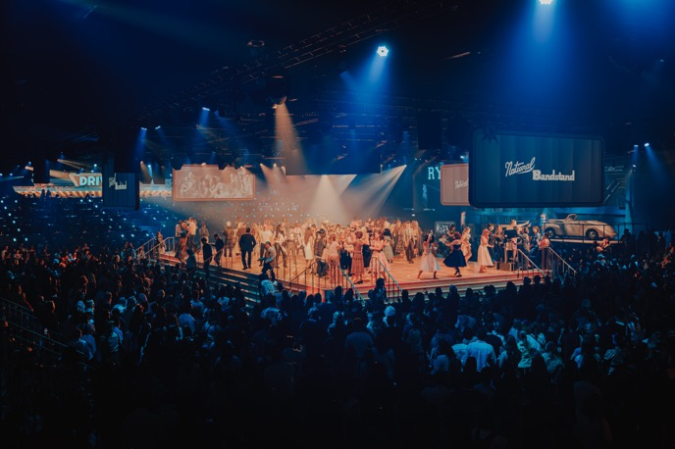
Marcus Blight, Technical Application Engineer at Sennheiser, provided outstanding support throughout the deployment. His expertise proved invaluable as the production pushed the boundaries of what was possible with wireless audio in such a complex environment.
“The speed of the prep was significantly quicker, the ease of deployment is 20 times easier and less complicated, and the robustness of the system is 10 times better,” notes Blight. “The amount of electricity being saved by not having massive amplifiers is also a plus. We’re not pulling loads of current or having lots of active devices turned on in one space. There’s an argument to say that the system is more sustainable as a result.”
The production’s technical complexity extended beyond traditional theatre requirements. With performances timed precisely to the original film and featuring a combination of live action and pre-recorded elements, the wireless system needed to support cueing while delivering seamless coverage across diverse performance spaces.

“Because of the complexity of everything else, with loads of tracking and loudspeakers all over the place, the radio deployment had to be simple, and Spectera allowed this,” explains Blight. “The complexity of doing this kind of production with a narrowband system would have been significant.”
Stage Sound Services, the rental partner for the production, had been preparing for this moment. General Manager, James Lewis, and Senior Account Manager, Jonathan Everett, had pushed to secure Spectera delivery specifically for this show, recognising its potential to transform their approach to large-scale wireless audio. Kevin Gwyther-Brown, Business Development Manager at Sennheiser, worked closely with Stage Sound Services throughout the process, building on extensive training sessions conducted earlier in the year.
 | “When I did a briefing with the cast and told them they only needed one pack for both IEMs and microphone, they burst into spontaneous applause,” recalls Gareth Fry  Photo credit: Luke Dyson
“The Sennheiser 6000 series has been pretty bulletproof in terms of a radio system, so when it came to Spectera, it was obvious that the build quality was going to be good,” says Lewis. “Earlier this year, Marcus and Kevin delivered a session on the Spectera system as part of our Training Tuesdays programme. The session was both engaging and highly informative. While there was a lot to take in, given that Spectera is a completely different technology to the RF systems we’re more familiar with, it provided a valuable opportunity to get hands-on with the product, as well as build an understanding of the theory behind it.
“It was also great to welcome students from a local university, giving them the chance to learn about the new technologies shaping our industry. The depth of technical knowledge Marcus brings on both RF and Spectera is very impressive, and he has a real ability to deliver that knowledge in a way that’s accessible and understandable for everyone.”
“Stage Sound Services has always been, and continues to be committed to Sennheiser and embracing new technologies,” Gwyther-Brown notes. “This production perfectly exemplified that partnership, with its team’s expertise and forward-thinking approach making the Spectera deployment a resounding success.”
The system’s advanced monitoring capabilities provided insight into performer equipment status, as Fry explains: “It’s a two-way system that’s in communication with the control racks. With the IEMs, we could see from the control system if somebody had accidentally turned down their IEM headphone volume, and the system can detect if they’ve accidentally pulled the headphone plug out.”
Production Sound Engineer, Tom Lishman, emphasises the critical role the system played in the show’s success. “We completely relied on the IEM technology to keep the cast in time in this huge building, and it worked on every stage,” he says. “I don’t think we could have achieved that with any other technology. We were aware we were doing things that hadn’t been done before.”
“We completely relied on the IEM technology to keep the cast in time in this huge building, and it worked on every stage,” Tom Lishman says.  Photo credit: Matt Crockett | 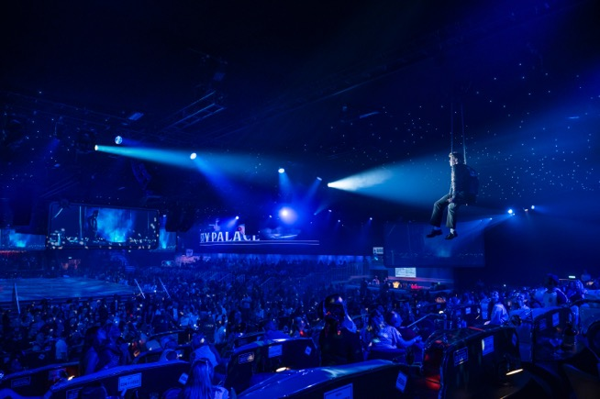
The deployment showcased Spectera’s flexibility in antenna connectivity, with outdoor antennas connected via fibre and internal antennas via Cat5e cable, with the two Spectera Base Stations themselves fitting within just 2U of rack space. This versatility, combined with the system’s range extension capabilities and advanced audio quality controls, proved essential for the production’s demanding requirements.
“The most impressive thing for us was the coverage area that it allowed, its flexibility, and its excellent sound quality,” concludes Lishman. “Needless to say, the quick setup also saved us a lot of time and effort.”
The production also utilised Sennheiser HM 200 headset microphones, completing a comprehensive wireless audio solution that met every challenge presented by this ambitious theatrical experience.
“We’ve been doing eight or nine shows a week for a couple of months and it’s been rock solid,” reports Fry. “From a long term reliability point of view, it’s feeling very good.”
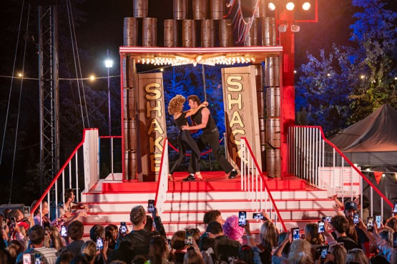 | Secret Cinema’s Grease has been a resounding success with audiences for months  Photo credit: Matt Crockett

[Ends]

The high-resolution images accompanying this media release plus additional images can be downloaded here.

About the Sennheiser Brand – 80 Years of Building the Future of Audio
We live and breathe audio. We are driven by the passion to create audio solutions that make a difference. This passion has taken us from the world’s greatest stages to the quietest listening rooms – and made Sennheiser the name behind audio that doesn’t just sound good: It feels true. In 2025, the Sennheiser brand celebrates its 80th anniversary. Since 1945, we have stood for building the future of audio and bringing remarkable sound experiences to our customers. While professional audio solutions such as microphones, meeting solutions, streaming technologies and monitoring systems are part of the business of Sennheiser electronic SE & Co. KG, the business with consumer devices such as headphones, soundbars and speech-enhanced hearables is operated by Sonova Holding AG under the license of Sennheiser.

www.sennheiser.com
www.sennheiser-hearing.com

EMEA Press Contact
Maik Robbe
Maik.Robbe@sennheiser.com
+49 (5130) 600 – 1028

